Memorandum

|  |  |
| --- | --- |
| Date: | 22 January 2020 |
| To: | Kim Swan, Clackamas River Water Providers |
| From: | Lucas Nguyen, Jamie Feldman, and Rob Annear, Geosyntec Consultants |
| Subject: | Groundwater Baseflow Study: Analysis Findings |

# Introduction

This technical memorandum (Memo) presents the key findings of Geosyntec Consultants Inc.’s (Geosyntec) Groundwater Baseflow Study of the Clackamas River Watershed to date. The purpose of this Memo is to provide the results and interpretation of the data analysis so that the Clackamas River Water Providers (CRWP) can make an informed decision of how to use the remaining funds in this project’s budget (~$15,000) and allocate funding for future efforts. At a later date, Geosyntec will communicate additional results and findings not presented in this Memo (such as a summary of our climate change literature review). Geosyntec evaluated historical data to determine spatial and temporal relationships between river flows and seasonal climatic inputs, including precipitation, temperature, snowpack water equivalent (SWE), and the timing of snowmelt. We observed several expected intra-year relationships (such as correlations between current water year snow water equivalent and streamflow); however, we could not identify definitive inter-year or multi-year relationships due to data limitations. This memo includes a list of recommendations, considering these limitations, to better understand the degree of resiliency of the watershed’s groundwater baseflow as low snowpack and/or low precipitation years potentially occur more frequently due to climate change.

Below we describe the analysis to date, our interpretations, limitations, and our future recommendations.

# Background

Low summer base flows in the Upper Clackamas River Basin are a function of the upper basin hydrology. The upper basin consists of primarily undeveloped forest within the Mt. Hood National Forest. The hydrogeology within the upper basin (above the City of Estacada) varies from High Cascade area down to Western Cascade area (Figure 1).[1]

To gain a better understanding of the hydrologic forcing of baseflow in the Clackamas Basin, a water balance first needs to be broken down into conceptual compartments to define how water travels. In theory, for the upper basin, the water stored as snowpack melts, primarily seeping into the unsaturated ground to become interflow. This water moves laterally through this subsurface zone, eventually either returning to the surface as overland flow, entering a stream, or recharging deeper groundwater storage reservoirs. This lateral groundwater flow proceeds downslope and enters the tributaries of the Clackamas River or the Clackamas River itself and ultimately the Willamette River.

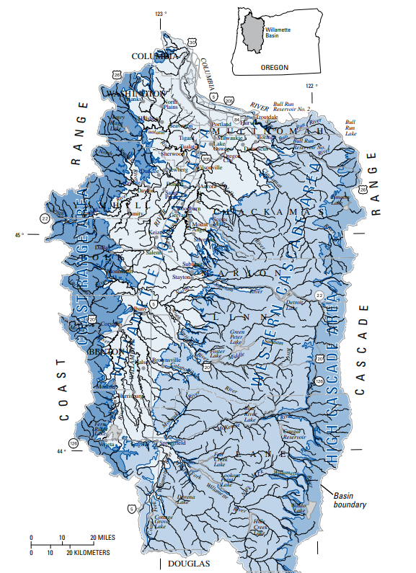

Figure 1: Geology of the Willamette River Basin. The dark blue of the volcanic High Cascade area and the light blue of the Western Cascade area dominate the Clackamas River basin. Source: Conlon, T. et.al. (2005). *Ground-Water Hydrology of the Willamette Basin, Oregon*.

The goal of this study is to trace water movement from snowpack, through groundwater, and into streamflow to the extent possible, and identify any functional relationship that can be used for watershed and drinking water management. Previous studies and literature suggest that the watershed’s hydrogeology could cause snowmelt to infiltrate into the young, open lava rock characteristic of the High Cascades, which recharges the groundwater in the lower sub-basins and may reappear in the streams after some extended residence time to boost late summer baseflow[2],[3]. The USGS published a seepage study of the Clackamas River stating, “The relatively large gain in streamflow between sites in the upper basin [upstream of Estacada] was primarily attributable to the contribution of groundwater, which is a key source of basin-wide streamflow during the summer”.[4] The theory explored in this and other studies is that young lava rock in the upper basin infiltrates water more readily into the groundwater than the surface-flow dominated Western Cascades area, and this water is expected to affect streamflow both seasonally and over the course of many years.

Within the confines of the data available, this analysis strove to test the findings of these studies as they pertain to the Clackamas Basin. The approach to evaluating base flow trends on this temporal and spatial scale includes both intra- and inter-annual analyses and pays close attention to both seasonal and long-term trends. Various temporal lenses were applied to the data such as seasonal rolling means, totals over specific months of the water year, and multi-year lags. Timeseries analysis, regressions, and time series decompositions were used to evaluate the available data.

# Methods

Our approach to this analysis began with the investigation of the relationship between groundwater and upper watershed hydrology. Preliminary examination consisted of visual timeseries analysis to identify annual trends and was followed by lagged correlations to quantify the strength of potential inter-annual relationships. We then attempted to assess the impact of upper watershed hydrology directly on streamflow. This was done with both single and multiple linear regressions to explore annual and inter-annual dependencies, and a seasonal decomposition of the time series to evaluate seasonal trends.

## Groundwater Level Relationship to Antecedent Snowpack

### *Correlation Analysis*

The groundwater data assembled by the Oregon Water Resources Department (OWRD) web tool provides observations taken at numerous gauges in Clackamas County extending from the early 1900’s to present day. The wells within the Clackamas Basin with more than 100 observations over their period of record generally range from the mid 1900’s with water level recorded approximately once every couple of months. The exception is USGS well 452033122195901, about miles north of Estacada, which starts in 2002 and records an observation almost every day, with some data gaps.

Groundwater level data was compared to SNOTEL data at the gauge locations Clackamas Lake (398), Clear Lake (401), and Peavine Ridge (687). Daily SWE data is available at these gauges beginning in 1980, while daily snow depth measurements do not begin until 2002. Thus, SWE was the primary metric used in analysis to represent snowpack. The metrics used were Snow Water Equivalent (inches) and Change In Snow Water Equivalent (inches), a delta value for SWE on daily timescale. The total precipitation metric used was Precipitation Increment – Snow-adj (inches) which is the daily precipitation depth adjusted for snow.

As we are interested in the relationship between snowpack and groundwater on the multi-year scale, linear regressions were evaluated at multiple lag-time intervals between 1 and 10 years. To execute this, the data was first aggregated on a water-year timescale (October 1st to September 30th). The groundwater level data and snow water equivalent data were averaged by water year. To simulate lag-time, the groundwater level data was then shifted back 1 to 10 years which allowed for the linear regression to compare snowpack to the groundwater level during future years when it may become expressed.

## Streamflow Relationship to Antecedent Snowpack

### Correlation Analysis

Mean daily streamflow data was acquired from USGS at seven stream gauge locations. The earliest gauge begins in 1908 (at Estacada, 14210000) and extends to present day. Several other gauges also begin in the early 1900’s and extend to present day with daily observations (allowing for some data gaps).

Streamflow data was compared to the snowpack data as previously introduced. A preliminary visual timeseries analysis was performed to inform the correlations. To smooth the daily variations in streamflow and highlight the seasonal variations, a backward-facing, three-month rolling window average was applied to the data before conducting the visual assessment. Wet and dry years as well as high and low snowpack years were also identified prior to inform the visual analysis. This was done by computing the total accumulated precipitation and the mean snowpack for each water year, then isolating years below the 25th percentile and those above the 75th percentile.

Linear regressions between streamflow and snowpack over different months of the year were then conducted to confirm seasonal relationships observed in the timeseries analysis. The specific months selected during the water year were isolated to compare snowpack during winter to the streamflow during the late summer. The mean snow water equivalent was identified during the winter months (November to March), and the mean flow value was obtained from August and September. Five months were used to encompass winter data aggregations to allow for annual variation in timing of snowfall. Maximum and minimum values over these windows were also analyzed in case they presented stronger correlations. These SWE and streamflow values for each water year were compared during the correlation.

To quantify the potential relationship between snowpack in the same water year as well as previous water years, a multiple regression was also performed. A volume-based metric was of the most interest, so total snowpack was calculated by summing the positive “Change In Snow Water Equivalent” values from the dataset over the winter months (November to March) and the total flow volume in the stream was calculated during August and September. The total late summer streamflow volume was compared to the total winter snowpack for the same water year, one water year previous, and two water years previous, and all combinations of these.

### Seasonal Decomposition

Seasonal decomposition of the timeseries data is the process of breaking down a timeseries into three separate parts: a long-term trend, and seasonal trend, and the residual left over components. The long-term trend is the data with any of the seasonally repeating components removed, such as spring runoff. The seasonal trend is a repeating cycle continuously found in the data, like spring runoff. Finally, the residual is what is left over, such as individual storm events that do not repeat year-to-year. There are many methods to decompose a timeseries, but at the core of most is a user defined period (such as yearly, monthly, or daily) that averages the data using a rolling window for all the available periods to identify similarities.

Streamflow and SWE data were prepared by averaging the data to monthly means (more resolute frequencies, such as weekly, did not produce better model performance) with a 12-month window size. A multiplicative decomposition was used by first removing the seasonal and trend components by applying a convolution filter to the data. A convolution filter uses local neighbors to compute the weighted average, thus not requiring a set window. The average of this smoothed series for each time period is the returned seasonal component. The remaining multiplicative series is the residual, as shown below:

Observed[*t*] = Long-Term Trend[*t*] * Seasonal[*t*] * Residual[*t*]

Where *t* is time.

The long-term trend, seasonal component, and residuals were then visually compared to SWE data.

# Data Availability

### Snowpack Data Availability

The SNOTEL data for Clackamas Lake (398), Clear Lake (401), and Peavine Ridge (687) were used. For analyses performed, the values were averaged across the gauges. This is supported by the spatial distribution of the gauges (Figure 2) as well as by the SWE distributions (Figure 3) between the sites, providing a reasonable indication that winter seasonal trends in the data are similar and can be averaged to approximate snow across the basin.

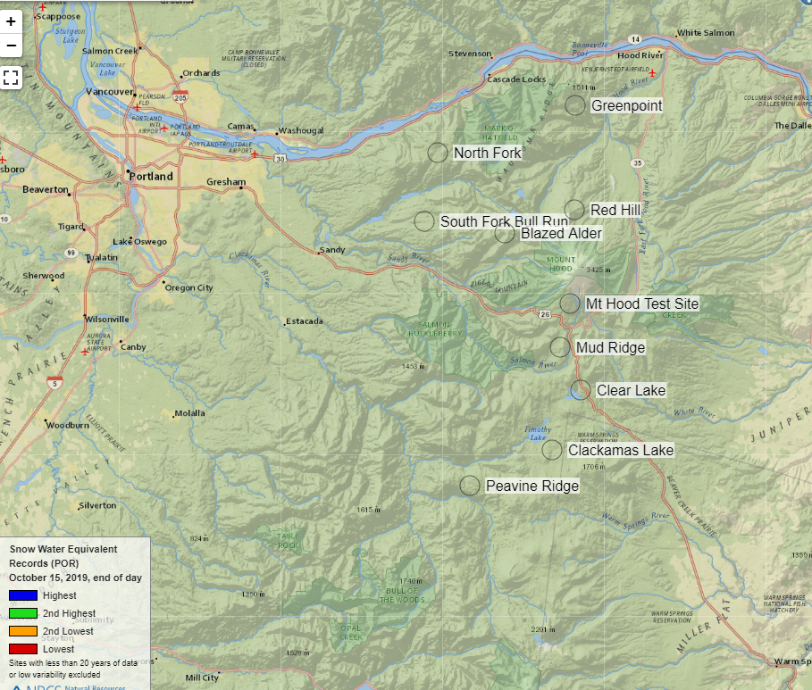

Figure 2: SNOTEL gauge locations

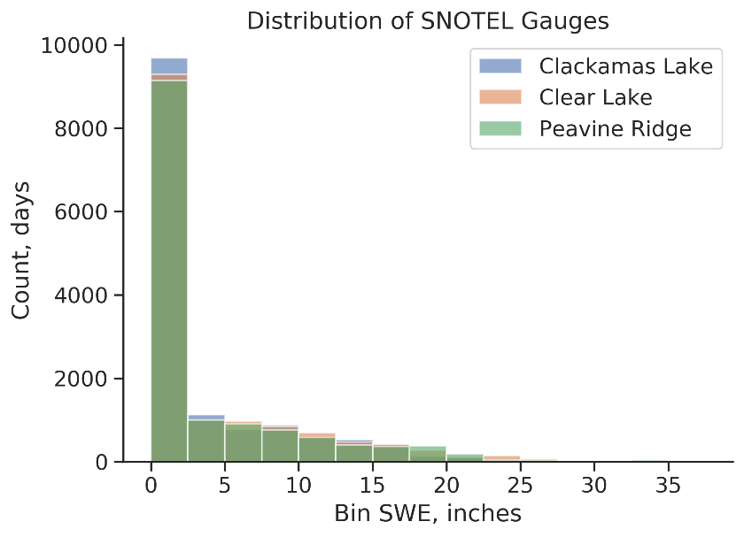

Figure 3: Distribution of values at three upper Clackamas Basin SNOTEL gauge locations. All three gauges show similar distributions.

### Groundwater Data Availability

The groundwater data assembled by the Oregon Water Resources Department (OWRD) web tool provides observations taken at numerous gauges in Clackamas County extending from the early 1900’s to present day. However, few gauges show continuous observations recorded over a multi-decadal period of record. Of the gauges with long-term records, there is only one in the upper basin, CLAC0014665 (Figure 4).

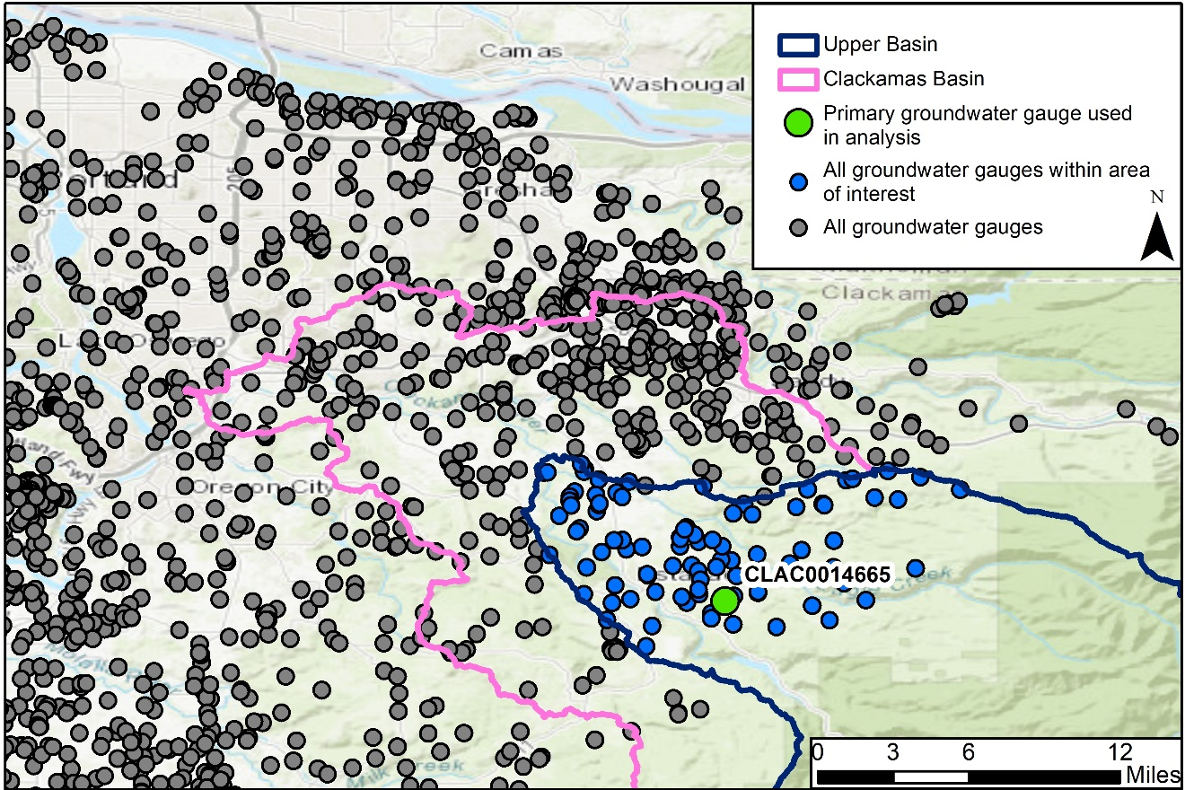

Figure 4: Location of primary groundwater gauge

The groundwater gauge in the upper basin, CLAC0014665, has a record consisting of 175 observations over 56 years beginning in 1963 as shown in Figure 5. It should be noted that Figure 5 shows the water level depth below the surface, so the higher the number the lower the water level in the aquifer.

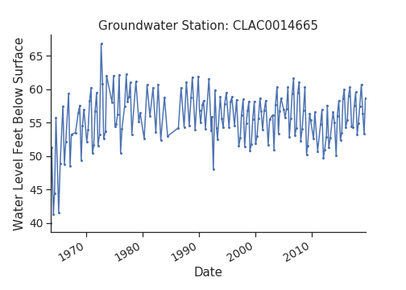

Figure 5: Period of record timeseries of OWRD Gauge CLAC0014665.

Correlations with other groundwater gauges in the region were assessed to determine if a synthetic patched record could supplement the data available for analysis. Correlations were limited to gauges with at least 20 monthly observations in common (or just under two years of data). A correlation matrix summarizing the results are shown in Figure 6. The darker the value, the higher the Pearson correlation coefficient. A high value (close to 1) indicates a strong positive correlation, low values close to 0 indicate no correlation, and negative values (close to -1) indicate strong negative correlation. In Figure 6, the white spaces indicate gauges with either no correlation or not enough data for a correlation. These results were corroborated by performing a similar correlation with Kendall’s statistic method. The specific correlation results of gauge CLAC0014665 are shown in Table 1. The figures and the table below indicate that, while the positive correlations between CLAC0014665 and other gauges were promising, these correlated gauges lie outside the area of interest, as shown in Figure 7, and at best only account for 60 percent of the variability (Pearson’s correlation coefficient) without regard for statistical significance (p-value).

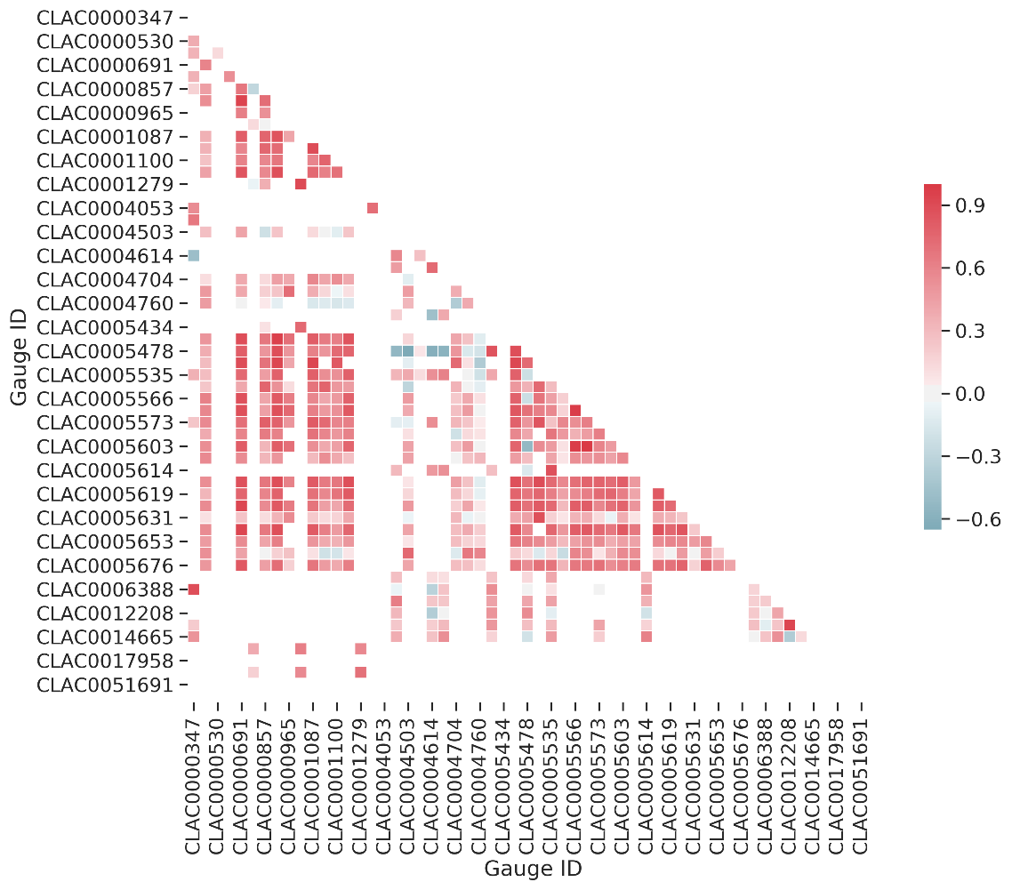

Figure 6: Groundwater gauge correlation grid. The darker the value, the higher the Pearson correlation coefficient. A high value (close to 1) indicates a strong positive correlation, low values close to 0 indicate no correlation, and negative values (close to -1) indicate strong negative correlation. White spaces indicate gauges with either no correlation or not enough data (>= 20 common dates) for a correlation.

Table 1: Groundwater gauges with positive correlations to primary gauge, CLAC0014665.

|  |  |
| --- | --- |
| **Correlations to Gauge CLAC0014665** | |
| **Gauge ID** | **Pearson's R** |
| CLAC0000347 | 0.51 |
| CLAC0004700 | 0.53 |
| CLAC0005535 | 0.46 |
| CLAC0005614 | 0.60 |
| CLAC0006859 | 0.53 |

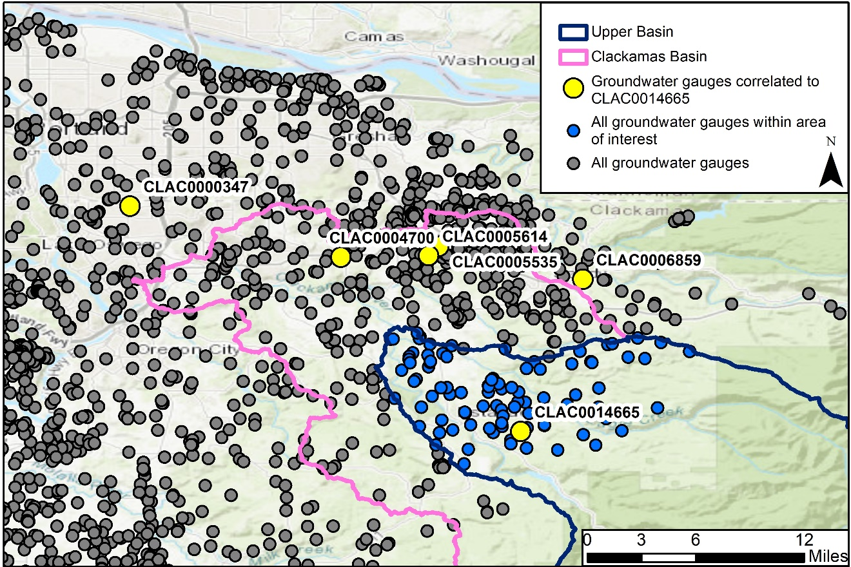

Figure 7: Locations of gauges correlated to primary gauge

### Streamflow Data Availability

The USGS daily mean streamflow data is available at multiple gauges throughout the basin beginning in the early 1900’s. Of these gauges, three locations were chosen as the primary gauges of interest as they sit at the downstream end of three main subwatersheds (two major forks and the upper main trunk line, see Figure 8). Between these three sections of the basin, spatial differences in the Clackamas Basin should be captured:

* + 14210000 at Estacada. Analysis of this gauge may provide insight into streamflow affected by snowmelt, PGE operations, and aquifers.
  + 14209000 at Oak Grove Fork above the hydropower operations. This gauge may provide insight into streamflow unaffected by PGE operations to more cleanly reveal hydrologic forcing.
  + 14208000 at Big Bottom. It was decommissioned in 1970. However, its data is still relevant to confirm that the subwatersheds for both forks of the upper basin experience similar forcing (as shown in subsequent analysis, below).

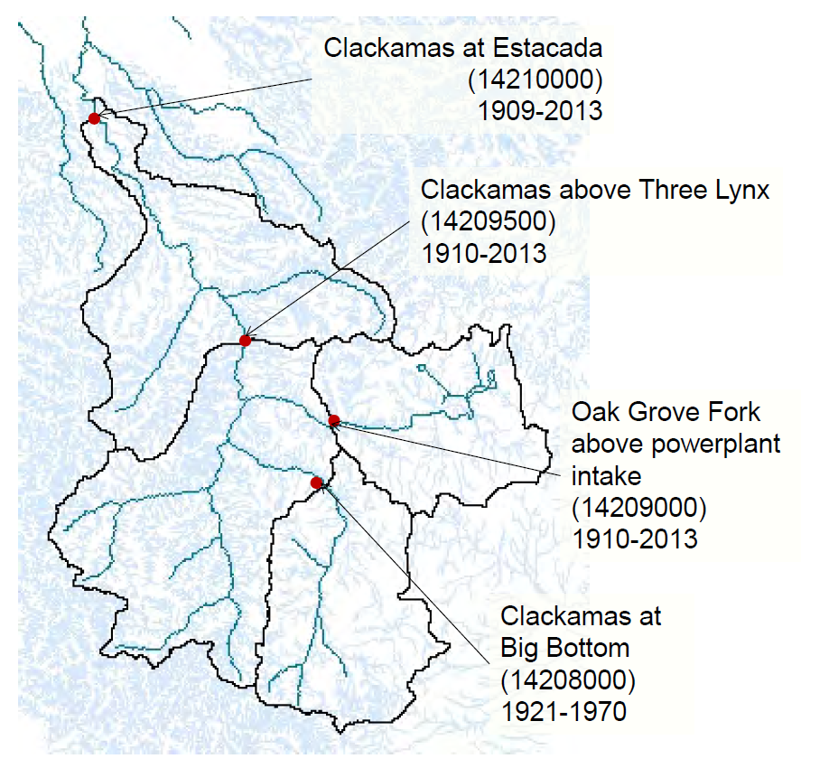

Figure 8: USGS streamflow gauge locations.

The primary USGS gauges of interest, 14209000 at Oak Grove Fork and 14210000 at Estacada, both have almost complete daily records from 1909 to present day. The secondary gauge of interest, 14208000 at Big Bottom has data only from 1920 to 1970. The record available for available USGS gauges are detailed in Figure 9.

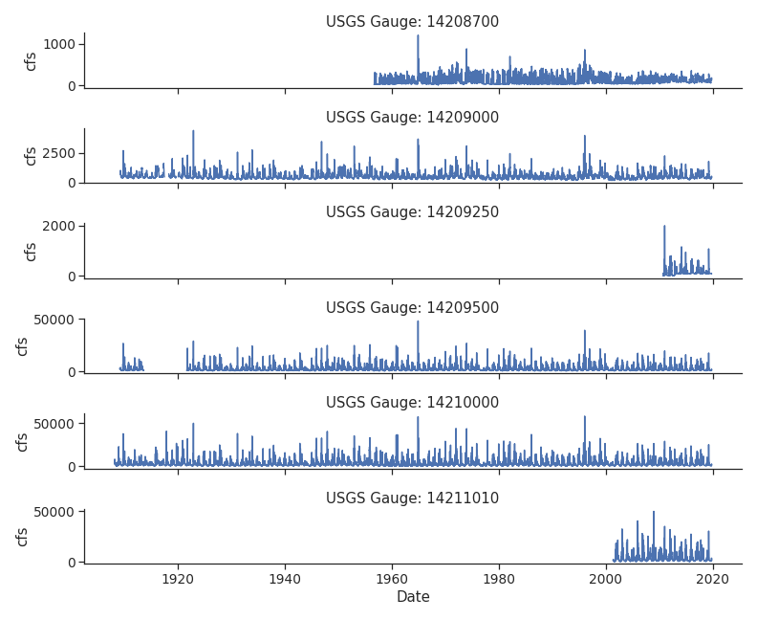

Figure 9: USGS gauge streamflow records

The weekly mean streamflow correlation between the Big Bottom gauge and the Oak Grove Fork gauge confirms that the Big Bottom fork experiences similar hydrologic forcing to Oak Grove Fork, as shown in Figure 10. The high Pearson’s r value (Pearson’s correlation coefficient) indicates a strong positive correlation between the two data sets. Additionally, the significant p-value of less than 0.01 indicates that there is little probability that an uncorrelated system could produce two datasets with a Pearson correlation coefficient at least as high as the one computed from these two datasets. The very faint blue halo around the linear regression line shows the 90th percentile confidence interval of the regression. A tight halo in this case is also an indicator of the strong correlation. The distributions of the data are displayed on the outer axis, demonstrating the relative lack of variability in the normal distribution of each fit to a kernel density estimator (a non-parametric way to estimate the probability density function, i.e. a data smoothing algorithm). Thus, Oak Grove Fork can be used as the representative upstream gauge for further analysis in lieu of data from Big Bottom.

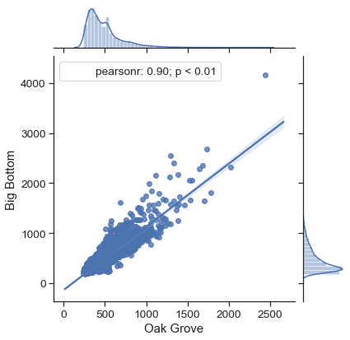

Figure 10: High positive correlation of weekly mean streamflow at both upper fork stream gauges

# Results

## Groundwater Level Relationship to Antecedent Snowpack

### Correlation Analysis

Using the annual average groundwater level at gauge CLAC0014665, a collection of correlations was drawn to water-year total snowpack and water-year total precipitation. Shifting the groundwater data back to assess potential lag times did not reveal significant relationships. The details of this correlation matrix can be viewed in Appendix A. The x- and y-axis of a correlation matrix mirror each other to show how each variable may (or may not) be (in)dependent of each other or correlated. In this case, the x-axis (independent) variable of interest is SWE, and the y-axis (dependent) variable to examine are the lagged groundwater levels. The center line figures show the distribution of each dataset. A linear regression line with a positive slope as well as a narrow halo would indicate a strong, positive correlation. For example, in a figure such as the one in Appendix A, a tight, negative correlation between SWE (x-axis) and groundwater (y-axis), would suggest that as SWE increases, the depth-to-ground-water measurement lagged a certain number of years decreases (in other words the groundwater elevation increases). However, no lag time in the data yielded a good fit.

## Streamflow Relationship to Antecedent Snowpack

### Correlation Analysis

The 3-month rolling average timeseries comparison suggests a potential relationship between maximum snow water equivalent and minimum flow for the same water year (Figure 11a and b). Several instances where this appears to be the case include the low snowpack year of 2015, which is followed by a low baseflow year, and the high snowpack year of 2008 which precedes a high baseflow year. The summary of high and low precipitation and snowpack years is provided in Table 2.

a)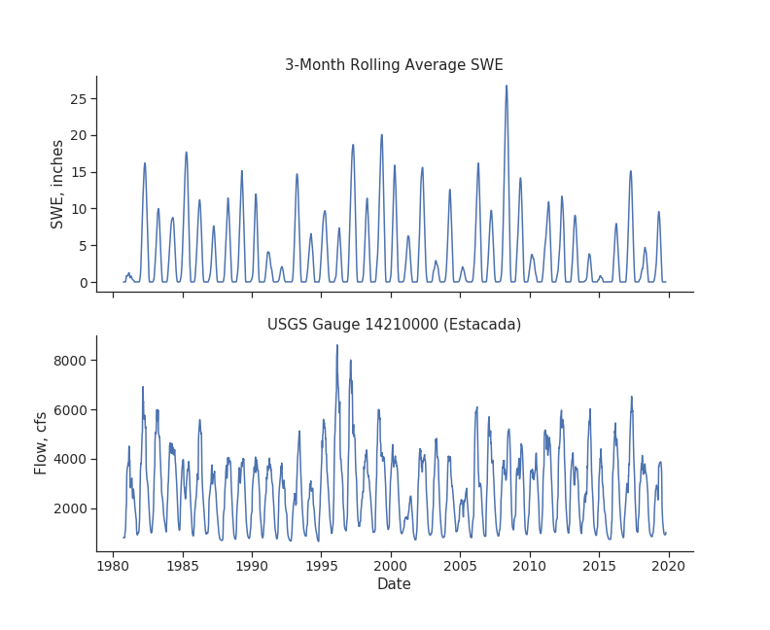

b) 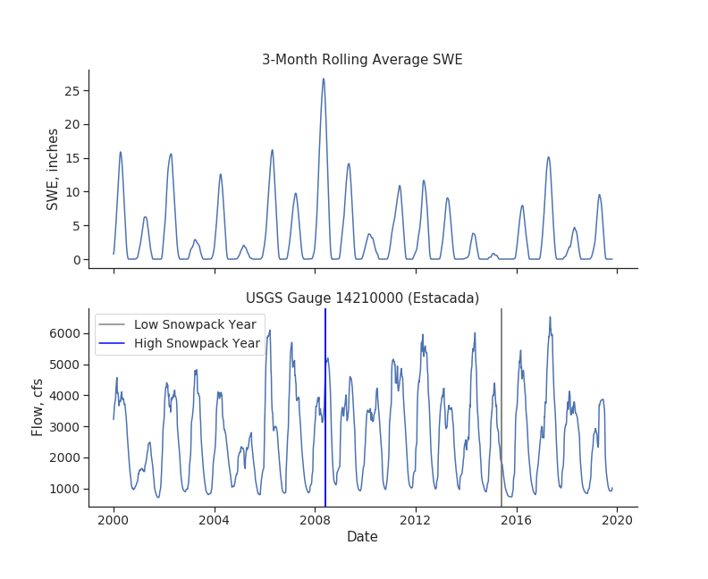

Figure 11: a) Full timeseries comparison for 3-month rolling average snow water equivalent and streamflow b) Examples of observed trend in early 2000’s

Table 2: Wet/dry years and high/low snowpack years by 25th and 75th percentile of the SNOTEL data

|  |  |  |  |
| --- | --- | --- | --- |
| **Wet Years** | | **Dry Years** | |
| **Year** | **Total Annual Precip (in)** | **Year** | **Total Annual Precip (in)** |
| 1982 | 70 | 1981 | 48 |
| 1983 | 72 | 1987 | 42 |
| 1995 | 71 | 1991 | 53 |
| 1996 | 80 | 1994 | 41 |
| 1997 | 91 | 2001 | 37 |
| 1999 | 75 | 2003 | 49 |
| 2008 | 70 | 2005 | 40 |
| 2011 | 67 | 2015 | 44 |
| 2012 | 66 | 2018 | 49 |
| 2017 | 70 |  |  |
| **High Snowpack Years** | | **Low Snowpack Years** | |
| **Year** | **Mean Annual SWE (in)** | **Year** | **Mean Annual SWE (in)** |
| 1982 | 5.9 | 1981 | 0.4 |
| 1985 | 6.5 | 1991 | 1.5 |
| 1993 | 4.8 | 1992 | 0.6 |
| 1997 | 7.1 | 2003 | 1.0 |
| 1999 | 7.1 | 2005 | 0.6 |
| 2002 | 5.6 | 2010 | 1.4 |
| 2006 | 5.3 | 2014 | 1.0 |
| 2008 | 9.6 | 2015 | 0.2 |
| 2009 | 4.7 | 2018 | 1.5 |
| 2017 | 5.1 |  |  |

Further investigation of this trend between SWE and streamflow consisted of linear regressions between winter mean SWE and August/September mean flow for the same water year. The stream gauge at Estacada (USGS # 14210000) demonstrates a strong correlation as indicated by the higher Pearson’s r and lower p-value (Figure 12). The p-value below 0.01 is statistically significant when assessing environmental data, meaning that the relationship between the Estacada gauge summer low flow and winter maximum snowpack may be strong enough to provide some limited predictive power (51% of the variability) with further investigation. The relationship between the mean late summer low flow at the Oak Grove Fork gauge and mean winter snowpack is less significant.

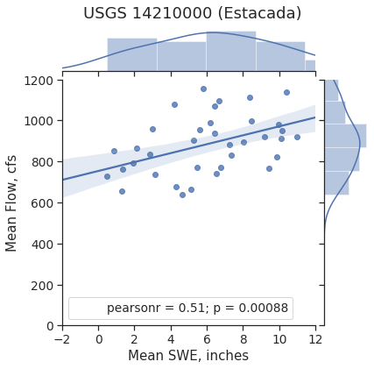

Figure 12: Correlation between mean winter snowpack and mean summer baseflow at Estacada.

A multiple regression analysis was conducted on the total snowpack in the same water year, previous water year, and 2-water-years-previous to evaluate potential residual effects on late summer streamflow volume. A group of single regressions between volume and SWE for each lagged scenario informed the results of the multiple regression, as shown in Figure 13. At both locations the best correlation was between the current year’s snowpack and the current year’s late summer streamflow volume, as demonstrated by the Pearson’s r values and the positive trend of the line. However, the multiple regression combinations for the lagged SWE scenarios did not result in improved correlations for either stream gauge. The adjusted R2 (the coefficient of determination which measures how well the data fits the regression) for the multiple regressions were all less than 0.4. No combination of the previous years’ SWE improved the fit significantly from the single regression. Because of the low determination, multi-linear regression assumptions were not evaluated.

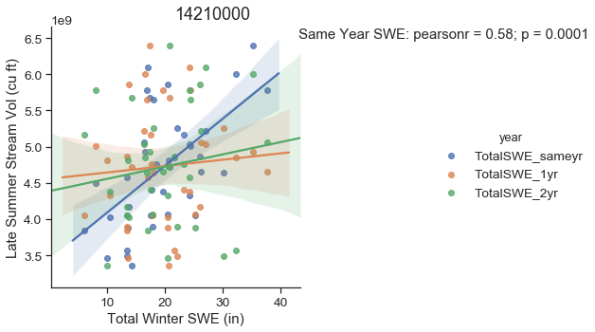

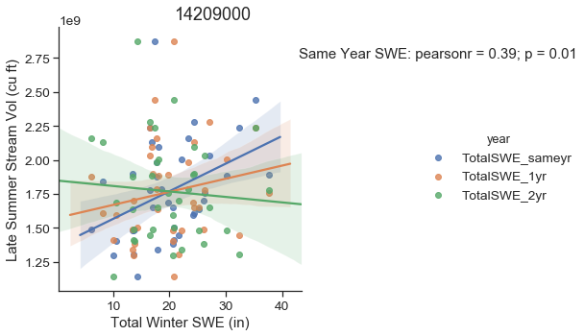

Figure 13: Single linear regressions between August/September total streamflow volume and winter total SWE for the previous three water years

### Seasonal Decomposition

Finally, the analysis included a seasonal decomposition of the streamflow timeseries that was compared to SWE. The monthly mean timeseries produced an adequate seasonal decomposition with both a long-term trend (base flow), regular seasonal component (seasonal base flow and seasonal runoff), and (normally distributed) residuals (single occurring flow events) as shown in Figure 14. All trends are the same length as the provided input data set. More resolute models using daily or weekly data did not provide better model performance. When looking at these figures, the observed data can be reconstructed by multiplying the long-term trend by the seasonal component and the residuals.

Figure 15 shows the seasonal component of flow and the residuals compared to SWE. The seasonal flow component lags winter snowfall and some of the local maximums and minimums of the residuals visually coincide with larger snow fall events of the same year.

Figure 16 shows a trend line comparison of the monthly mean time series decomposition of streamflow at USGS Gauge 14209000 (Oak Grove Fork) to monthly mean SWE. Statistics such as r-squared and p-values are purposefully omitted as this comparison is for visual analysis only. A double-humped seasonal trend is clearly observed at both gauges, the context for which is examined in the discussion section.

Residuals of the streamflow time series are usually normally distributed, as shown in the figure, suggesting that the seasonal and trend flow components adequately describe the data. SWE and both the seasonal and residual component show some positive correlation. This relationship is expected as SWE at the end of the season should be correlated to seasonal spring high flows and as the snow melts as does the seasonal flowrate. Outliers of either low or high snowpack years could be captured in the residual component of the streamflow decomposition, but this was not observed. The long-term trend is interesting because 1) variation remains in the data, and 2) it does not show (any visually obvious) upwards or down-wards trend. The long-term trend does not correlate well with SWE data and thus must be a factor of base flow from groundwater. Further analysis could explore decomposition of the SWE data set to statistically correlate the seasonal components of the SWE data and seasonal components of the streamflow data to remove the noise (or banding as seen in Figure 16).

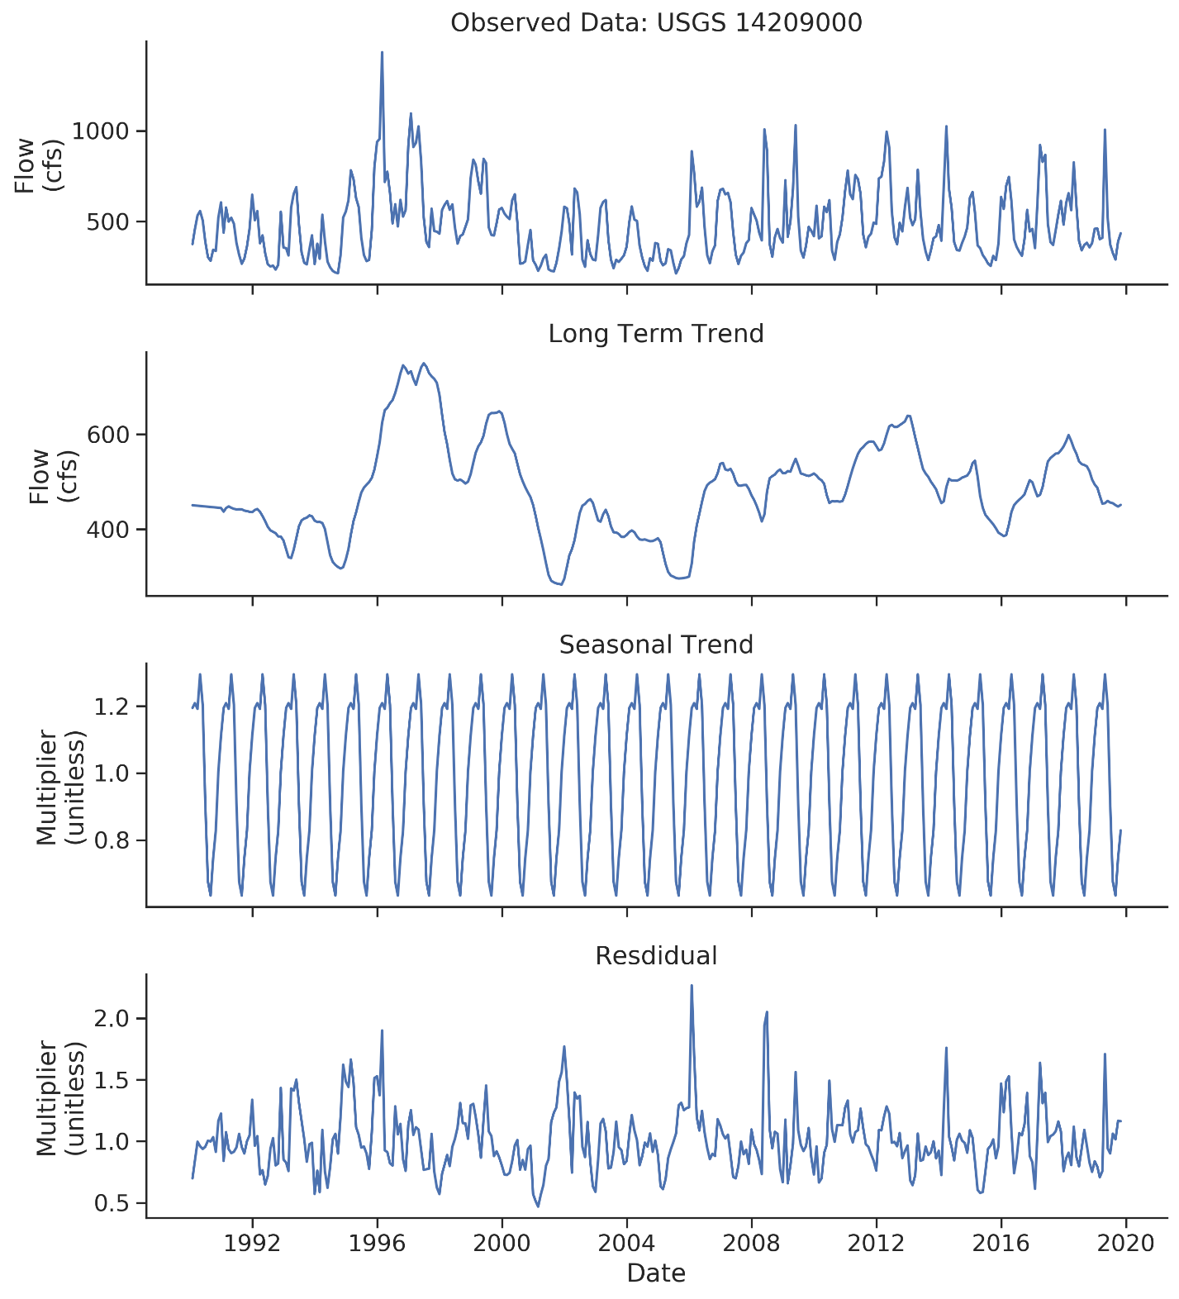

Figure 14: Season decomposition of monthly mean streamflow at USGS Gauge 14209000 (Oak Grove Fork). Top panel: Monthly mean observations. Second panel: Long term trend from decomposition. Third panel: Seasonal trend form from decomposition. Final panel: Residuals from decomposition.

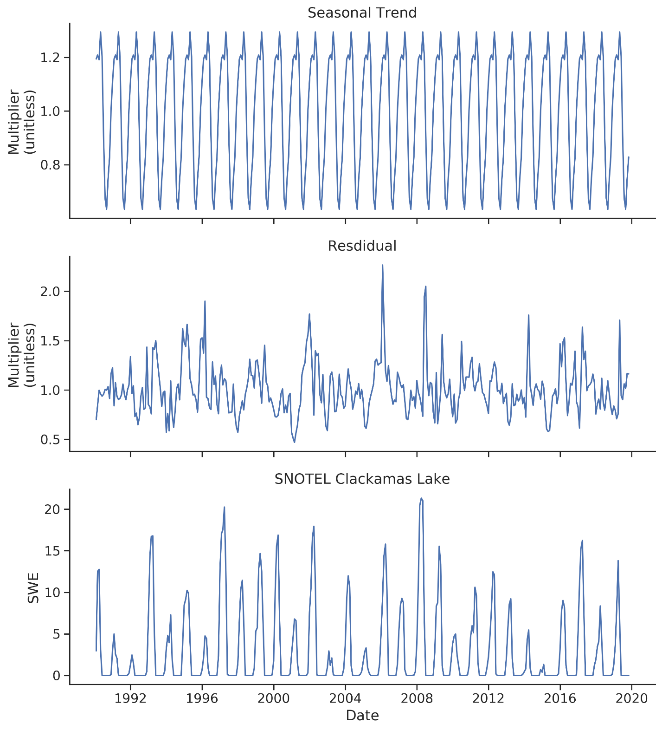

Figure 15: Time series comparison of the monthly mean time series decomposition of streamflow at USGS Gauge 14209000 (Oak Grove Fork) seasonal trend and residuals to monthly mean SWE.

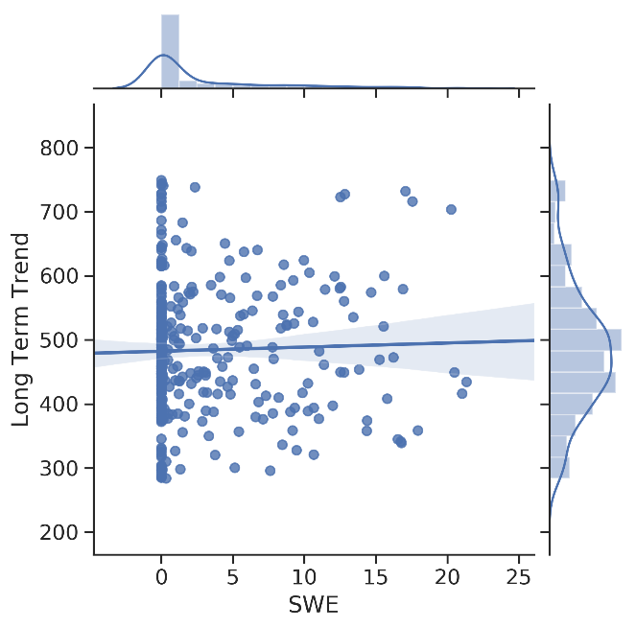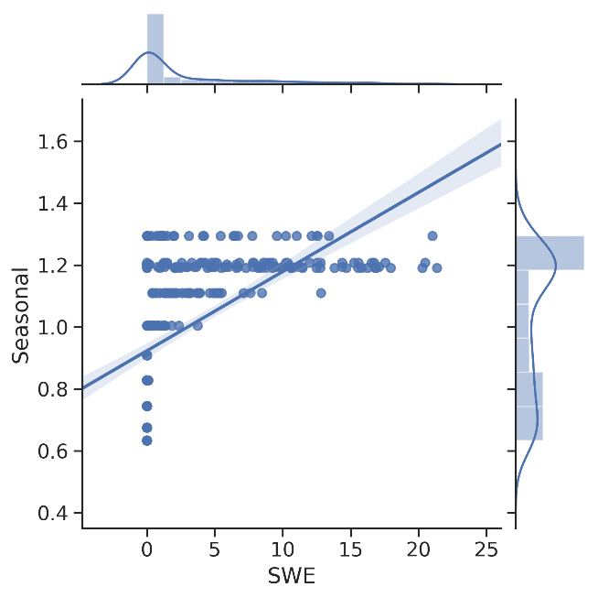 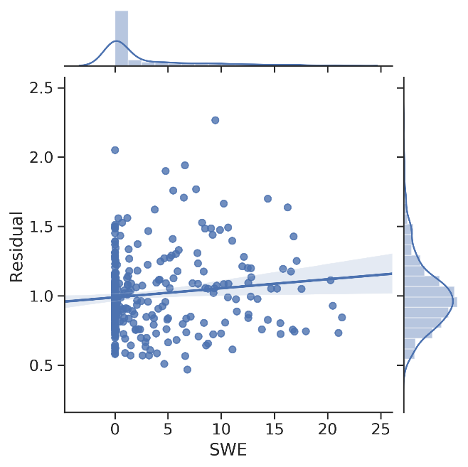

Figure 16: Trend line comparison of the monthly mean time series decomposition of streamflow at USGS Gauge 14209000 (Oak Grove Fork). The shaded area around the trend line represent the 90th percentile confidence interval. Outer margins show distribution of each result or dataset fit to a kernel density estimator. Residuals of the streamflow time series are normally distributed suggesting that the seasonal and trend components adequately describe the data.

# Limitations

### Limitations of Data

The lack of groundwater gauges with more than 20 observations over a multi-decadal period of record within the upper basin presented a major obstacle for analyzing the traversal of water between the snowpack and groundwater conceptual compartments. The specific limiting factors that resulted in this sparsity of data were a coincidence of:

* Lack of wells maintaining long-term observations in the upper Clackamas Basin.
* Wells with periods of record that did not overlap, preventing effective correlations to expand/patch data gaps in the records.
* Lack of hydrogeologic and stratigraphic information to allow expansion of the area of interest to include connected groundwater aquifers.

This hindered the types of analyses that were performed as well as the insights gleaned from what was done.

### Limitations of Analysis

The analysis presented here provides an overview of key potential relationships in the watershed. Several descriptive statistics originally included in the Scope of Work (SOW), such as boxplots and histograms of individual datasets, were excluded from this report and can be provided as-is or in a future report upon request.

Quantile-quantile (QQ) plots are typically used to verify strong correlations. In the absence of strong statistically significant correlations QQ plots were dismissed from the analysis.

We did not analyze results from the Mann-Whitney rank sum test after observing poor statistically significant relationships between SWE and streamflow in preceding analyses.

We did not analyze results from the Seasonal Kendall’s tau to statistically identify long term temporal trends in flow rate because no long-term trend was visually observed after time series decomposition.

# Discussion

The groundwater gauge CLAC0014665 did not demonstrate a clear relationship to upper watershed hydrology. Should more attention be dedicated to mapping the geology and groundwater connectivity of the region, the area of interest spatially restricting the relevant groundwater gauges could be refined. This may allow for additional groundwater gauges with long term records and statistical significance to CLAC0014665 to be viable candidates for analysis.

The expected relationship between groundwater and snowpack was only partially discovered in the correlations for tested lag-times of the groundwater data. The negative correlation between SWE and groundwater level of the same water year provided a good gut check, as it appears high snowpack years correlate roughly to lower depth-to-groundwater, and therefore higher groundwater elevation, of the same year. This makes sense, as the well-report for CLAC0014665 (Appendix B), shows that it is a relatively shallow well and thus hydrology is expected to be expressed at that gauge station rapidly. However, the trend is not strong enough to draw a quantitative relationship. The part of the theory that could not be demonstrated is the multi-year trends. None of the other lag times for groundwater exhibited a strong correlation to SWE, leaving the question of snowmelt’s residence time in the deeper groundwater unanswered. A negative-sloping line was expected after some lag-time as water hypothetically moves from the upper zone down toward the lower watershed. This is supported by discussions of the hydrogeology of the High Cascades versus the Western Cascades. The indication that the subwatershed above the Oak Grove Fork stream gauge is 75% High Cascades geology suggests that much of the snowpack may be entering deep groundwater storage and reappearing far down stream.[5] However, additional research on the geology, hydrogeology, and aquifers of the upper basin would be required to explore this theory further.

The relationship between streamflow and snowpack is clearer; the mean winter SWE is positively correlated to the mean late summer streamflow as expected. This is most observable in the correlation for the Estacada gauge. However, the goal of quantifying the trend both within a water year and across multiple years to provide predictive power of summer low flow could not be met. The descending correlation coefficient value between the late summer streamflow volume and the total snowpack for the same, previous, and two years previous at the Oak Grove Fork gauge is interesting as it hints at the groundwater dynamics of the upper watershed, however the strength of both these single correlations and the multiple regressions are insufficient to draw conclusions. It’s possible that the relationship is being masked by confounding factors such as PGE dam operations, or multi-year groundwater interflow that was not quantified in the previous analyses.

The seasonal decomposition revealed some promising trends and was effective in demonstrating some expected relationships. The double-humped seasonal trend was anticipated, especially considering the high-watershed position of the stream gauge, as illustrated in the literature.[6],[7] The double-humped seasonal hydrograph is characteristic of wet winter flows due to precipitation followed by a peak during spring snow-melt. Further analysis could explore decomposition of the SWE data set to statistically correlate the seasonal components of the SWE data and seasonal components of the streamflow data to remove the noise (or banding as seen in Figure 16). Additionally, because the long-term trend does not correlate well with SWE and no visual trend was observed, several different groundwater sources with different resident times could be factors in this unpredictable base flow pattern.

# Recommendations

Based on current available data, gaps remain in the conceptual model for the basin. Inter- and multi-year relationships of SWE to groundwater and river baseflow are still unknown. Two options exist that can help fill these gaps: 1) additional data collection, and 2) basin hydrology modeling. Additional data collection could put an answer off for years and still requires a desktop analysis of the hydrogeology (which must also be done to build any model and could inform model selection). Developing a preliminary model can get answers sooner and inform where to collect future data, if necessary.

Following the findings of this analysis, our primary recommendation is to develop a linked snowpack and groundwater hydrology model. We believe a model could be adequately calibrated to provide predictive power given the availability of current long-term climactic datasets (SWE, snow depth, air temperature, and precipitation), flow data, and the high correlation between the Oak Grove and Big Bottom USGS gauges indicating similar hydrologic forcing in the two subwatersheds. Several models exist that would be suitable for this analysis, such as the National Weather Service’s SNOW-17 model and various soil moisture accounting models that generate runoff and interflow in a basin, such as Precipitation Runoff Modeling System (PRMS). In addition, if a hydrology model were to be developed, the work done by PSU and the prior work on the Pollutant Load Model done by Geosyntec could be leveraged.

Additional recommendations include:

Use time series decomposition on the SNOTEL data (SWE) to correlate seasonal trends and residuals in streamflow. This analysis would show how much of the seasonal variability and residual variability within the same year of streamflow can be explained by SWE alone. Any remaining variability in streamflow would be due to groundwater or confounding factors, such as dam operations.

Statistically test similarities (or differences) between correlated spatial trends (e.g. Oak Grove and Big Bottom, SNOTEL Sites, etc.). This statistical testing is part of the current SOW but would not provide any predictive power outside of better quantifying a linked snowpack and groundwater model. This analysis would primary be performed using the Mann-Whitney rank sum test.

We also recommend identifying existing groundwater wells to add more frequent monitoring. If CRWP can gain access rights to a pre-drilled well, adding a pressure transducer and data logger is low cost effort in terms of both hardware and staff hours. This effort would benefit both this current effort and a linked snowpack and groundwater model. Our current understanding from CRWP is that local nonprofits are applying for grant funds to develop restoration projects in the basin which may include up to 15 wells to be in place. While it’s unclear how deep these wells may go, it may represent an opportunity to collaborate and obtain additional data.

The results of this study so far show that a more complex interaction between snowpack, groundwater, and baseflow is occurring than can be described using timeseries and correlation analysis alone. The quantification of groundwater residence time and the impact of snowmelt on baseflow would greatly benefit from the identification and monitoring of aquafers in the high upper watershed.

Following any of these actions, it may then be more feasible to readdress a confounding factors analysis to isolate the effect of variables such a precipitation, temperature, PGE operations, and multi-year groundwater interflow. This additional step may inform a potential model as well as interpretations of the results detailed in this memorandum. Any of these actions, and certainly an integrated hydrology model, would support any future climate change analyses and improve our understanding of how increased precipitation and less snowpack in the basin could impact baseflow.

*****

# Appendix A

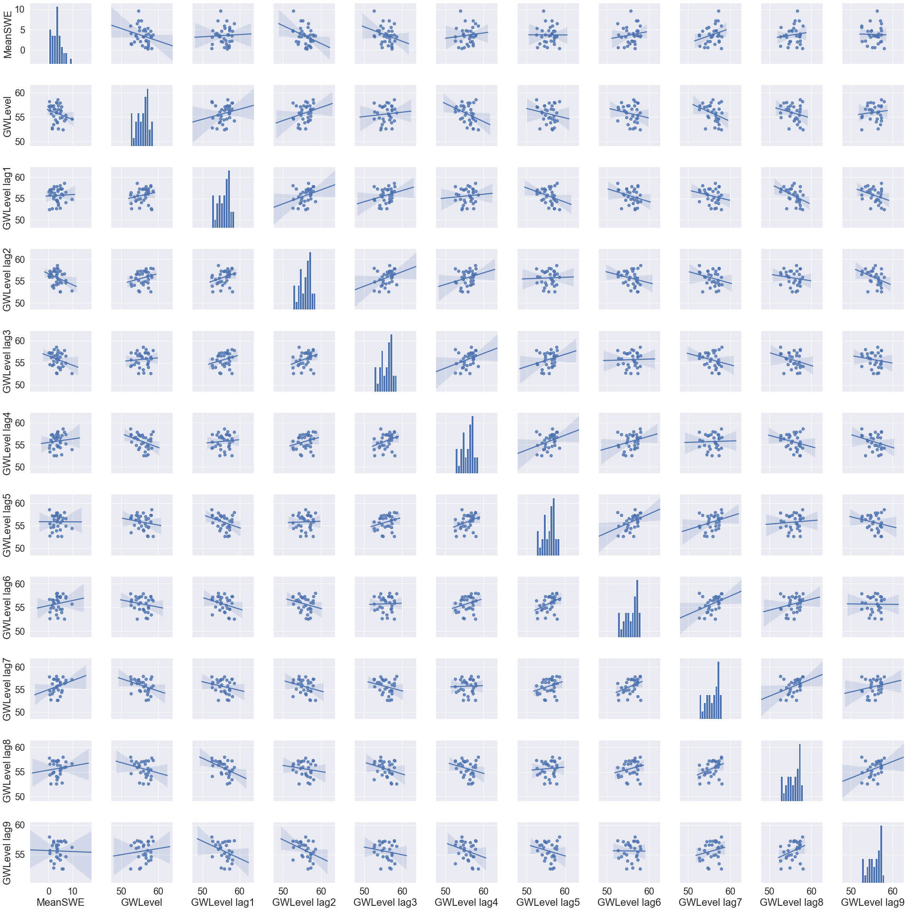

# Appendix B

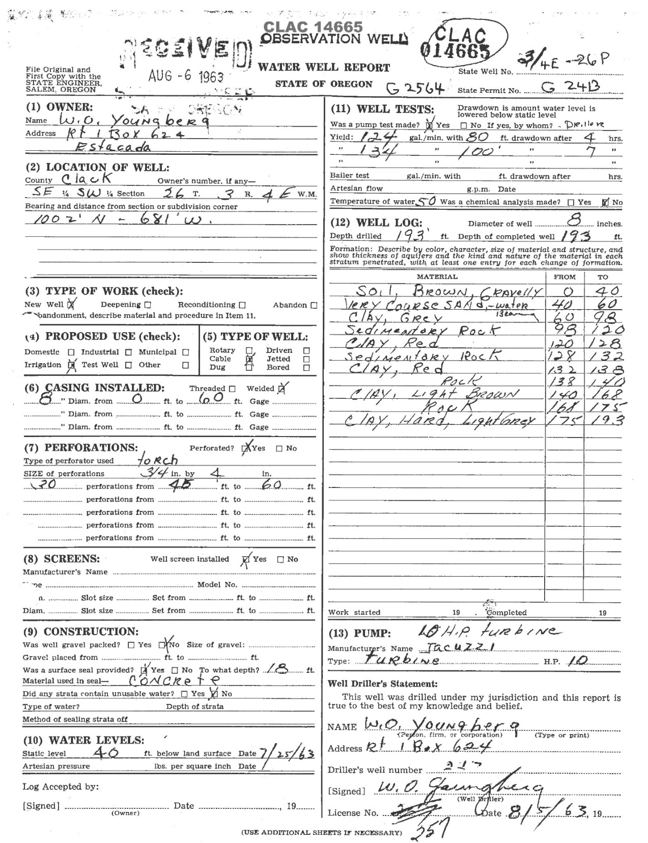

1. Conlon, T. et.al. (2005). *Ground-Water Hydrology of the Willamette Basin, Oregon*.
2. Grant, G. *The Ultimate Hydrologic Sponge: how the plumbing system of the Cascades controls streamflow and response to climate change in the Willamette (and Clackamas) Basins.* USDA Forest Service PNW Research Station. Presentation.
3. Tague, C., Grant, G. et.al. (2007). *Deep groundwater mediates streamflow response to climate warming in the Oregon Cascades.* Climatic Change (2008) 86:189-210.
4. Lee, K. (2011). *Seepage Investigations of the Clackamas River, Oregon.* <https://pubs.usgs.gov/sir/2011/5191/section4.html>
5. Grant, G. *The Ultimate Hydrologic Sponge.* p.21.
6. Grant, G. *The Ultimate Hydrologic Sponge.* p.18.
7. Tague, C., Grant, G. et.al. (2007). *Deep groundwater mediates streamflow response to climate warming in the Oregon Cascades.* p.15.